bellabeats_rmarkdown

Kiara Thiam

2023-05-13

# Case Study: Bellabeats

#### Objection:

Determine how trends in smart fitness device usage can influence Bellabeat’s marketing strategy.

#### Disclaimer:

This analysis is based on a very limited data set, and would not be indicative of the smart fitness device customer base as a whole. We also don’t know anything about the participants themselves. Factors such as age, gender, location, etc. are unknown in this study.

## Setting up my Environment

Installing the packages I’ll likely need to analyze my data.

install.packages("tidyverse")

## Installing package into '/cloud/lib/x86_64-pc-linux-gnu-library/4.3'  
## (as 'lib' is unspecified)

library(tidyverse)

## ── Attaching core tidyverse packages ──────────────────────── tidyverse 2.0.0 ──  
## ✔ dplyr 1.1.2 ✔ readr 2.1.4  
## ✔ forcats 1.0.0 ✔ stringr 1.5.0  
## ✔ ggplot2 3.4.2 ✔ tibble 3.2.1  
## ✔ lubridate 1.9.2 ✔ tidyr 1.3.0  
## ✔ purrr 1.0.1

## ── Conflicts ────────────────────────────────────────── tidyverse_conflicts() ──  
## ✖ dplyr::filter() masks stats::filter()  
## ✖ dplyr::lag() masks stats::lag()  
## ℹ Use the conflicted package (<http://conflicted.r-lib.org/>) to force all conflicts to become errors

library(readr)  
library(ggplot2)  
library(dplyr)  
library(lubridate)  
library(tidyr)  
library(tibble)  
  
install.packages("here")

## Installing package into '/cloud/lib/x86_64-pc-linux-gnu-library/4.3'  
## (as 'lib' is unspecified)

install.packages("skimr")

## Installing package into '/cloud/lib/x86_64-pc-linux-gnu-library/4.3'  
## (as 'lib' is unspecified)

install.packages("janitor")

## Installing package into '/cloud/lib/x86_64-pc-linux-gnu-library/4.3'  
## (as 'lib' is unspecified)

library(here)

## here() starts at /cloud/project

library(skimr)  
library(janitor)

##   
## Attaching package: 'janitor'  
##   
## The following objects are masked from 'package:stats':  
##   
## chisq.test, fisher.test

install.packages("readxl")

## Installing package into '/cloud/lib/x86_64-pc-linux-gnu-library/4.3'  
## (as 'lib' is unspecified)

library(readxl)

## Installing the daily activity data set

daily_activity_df <- read_excel("daily_activity.xlsx")

### Cleaning up the data a little

trimmed_activity_df <- rename(daily_activity_df, 'ID' = "Row Labels", 'average_total_steps' = "Average of TotalSteps",  
 'very_active_minutes'='Average of VeryActiveMinutes', 'fairly_active_minutes'='Average of FairlyActiveMinutes',  
 'lightly_active_minutes'='Average of LightlyActiveMinutes',  
 'sedentary_minutes'='Average of SedentaryMinutes') %>%  
 select(-"Average of SedentaryActiveDistance",-"Average of VeryActiveDistance", -"Average of ModeratelyActiveDistance",  
 -"Average of LightActiveDistance")

### Activity plot

activity_plot <- ggplot(data=trimmed_activity_df) +  
 geom_point(mapping=aes(x=ID, y=lightly_active_minutes), color="red") +  
 geom_point(mapping=aes(x=ID, y=fairly_active_minutes), color="blue") +  
 geom_point(mapping=aes(x=ID, y=very_active_minutes), color="green") +  
 labs(title="Average Daily Activity in Minutes",  
 caption="Crowd-sourced Fitbit datasets 03.12.2016-05.12.2016  
Furberg, Robert; Brinton, Julia; Keating, Michael ; Ortiz, Alexa)") +  
 ylab("minutes")

activity_plot +  
 theme(axis.text.x = element_text(angle = 45, vjust = 1, hjust=1))

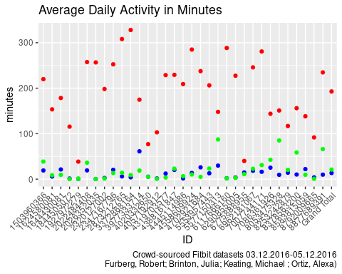

## Calories Plot

First, load and tidy the daily calories data.

daily_calories <- read_excel("daily_calories.xlsx")

This bar graph shows that, on average, smart device wearers range from sedentary to moderately active.

daily_calories_df <- rename(daily_calories, "ID"="Row Labels", "average_calories"="Average of Calories")  
  
ggplot(data=daily_calories_df) +  
 geom_bar(mapping=aes(x=ID, y=average_calories), stat="identity", fill="blue") +  
 theme(axis.text.x = element_text(angle = 45, vjust = 1, hjust=1)) +  
 labs(title="Calories Burned", subtitle="Average number of calories each participant burned daily",   
 caption="Crowd-sourced Fitbit datasets 03.12.2016-05.12.2016   
 Furberg, Robert; Brinton, Julia; Keating, Michael ; Ortiz, Alexa)")

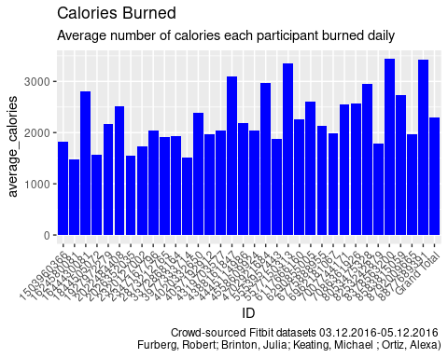

## Summary

Smart fitness device users are more sedentary than moderately active. We know that the average adult woman burns around 1600-2400 calories per day. The data from the FitBit dataset I analyzed shows the participants burn an average of about 2300 per day. An olympic athlete burns twice that much.

## Conclusion

Based on this very small sample, I would recommend Bellabeats tailor its marketing strategy to focus on people who just want to be a little more active and not so much on people who are already living very active lifestyles (marathoners, athletes, etc.). Your average, everyday mom who could use a little motivation to add some physical activity to her routine would benefit greatly from Bellabeats’s products!